**Module Name: Web Authoring**

**Module Code: 5N1910**

**Assignment Name: Project Phase I**

**Weighting: 20%**

**Your Name: Steven Joyce**

**Class Group: Computer Science**

**Tutor Name: Darren Stones**

**Issue Date: 3 October 2016**

**Due Date: 7th November 2016**

**Web Authoring Project**

**Identify Website topic: Irish Sporting Legends**

**Identify your target market**

The target audience for this website is sports fans. The website has a mainly national audience and can be read by anyone no matter what their age is.

**List your site objectives**

With this website, I want to educate people on the rich sporting history the Republic of Ireland has despite our small population. I also want to pay homage to the forgotten legends of Irish sport.

**Create site map and logical navigation solution**

**Site map diagram**



**Logical navigation solution(s)**

The navigation solutions I use will be tabs at the top of each page to go onto the next page. On the front page, I have buttons linking you to each page of the website by their sports.



**Sketching of initial design concepts**

I used the website: http://sneakpeekit.com/ to sketch my website design after printing them out.

+

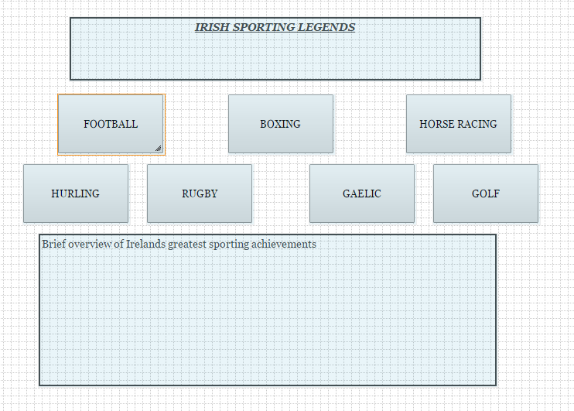

This is my template for every other page of my website.

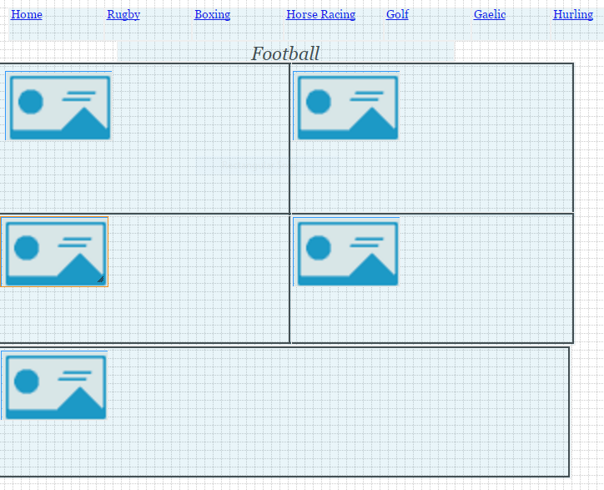

**Identify tools for creation and maintenance of website including:**

To create the website, I will use HTML and CSS. I will also you a web host such as Wix to publish my website.

**Design a user interface for specified target audience to include:**

I used a website called <http://framebox.org/> to create my website design. Using this website I have realised the importance of contrast, repetition, alignment and proximity to building a website.

**Contrast:** I will have a white background because it makes the black writing stand out. It also enhances the ability of the picture to stand out and draw the reader into the text.

**Repetition:** I have begun to understand that to make the reader view the website with ease you need to make the website have a reoccurring layout.

**Alignment:** The structure of a website need to have symmetry to make the viewer see all the info properly and without any issues. Therefore, I chose to have all the text and images are in line with one another.

**Proximity:** The importance of proximity cannot be understated because the way everything is layout will either hinder of ease the ability of a reader to view the website. Therefore, I chose to have all writing in line with one another.